|  |  |  |  |  |
| --- | --- | --- | --- | --- |
| FPT University Logo Vector (.EPS) Free Download  **FPT International School**  **---**  **PROJECT REPORT**   |  |  | | --- | --- | | Semester: 1  Group: 4   * Student1341702  Đỗ Hoàng Minh Tuấn * Student1341549 Dương Đức Vinh * Student1341568 Lê Quốc Anh * Student1341525  Trần Lê Hoàng * Student1342034  Đỗ Danh Bản | | |  |  | |

**Table of Contents**

1. eProject Synopsis 04
2. eProject Analysis 05
3. eProject Design 07
4. Sitemap 08
5. Flowcharts 08
6. UI/UX Design 13
7. Home page 14
8. Products 19
9. Product Detail 20
10. Products by Color 22
11. Sale products 23
12. Stores 24
13. Store detail 25
14. About us 26
15. Policies 29
16. Contact us 37
17. Sign in / Register 38
18. Check out 41
19. Compare products 42
20. Admin pages 46
21. Developer’s Guide 58
22. User’s Guide 66

## **I. Synopsis**

### **a. Problem Statement**

A-1 uniforms was founded in 2016 and since then they have been one of the leading **Uniform Manufacturers in the country.** they supply many schools in country and they give them the best uniforms. They supply affordable school uniforms for girls and boys. When clients come, they cater to client’s vision. As a team of professionals they understand what clients want and deliver the best results.

At A-1 uniform designs are innovative and there are always fresh and new ideas for each and every client. The textiles are of excellent quality and they make each uniform according to the size requirements given. The fit is ingenious and they provide with the best. A-1 uniform is a part of a continuous strategic process of creative inputs from experts in the field. They consider each client differently and ensure the satisfaction with the end results. Each client is given the uttermost importance.

### **b. Requirements**

The Website will be created based on the following requirements.

1. Home page should be created using Sections with appropriate logos, headers can be added to show pictures of the clothes.

2. The website must contain links to navigate through any category for information.

3. The website should display a menu which contains options for a brief introduction of the various available products, the location of the store and any other information if required.

4. The information should be categorized by the brand name of the product such as if the User just wants to see the shirt or any other store product then they can click the Link/button/menu , etc and can only view such Brand products.

5. When user selects any particular brand, a list of product categories for that brand will be displayed

8. There should be a “Contact Us” page which will have the Address of the Company to be displayed using the GeoLocation API (eg GoogleMaps) and an email address which when clicked will invoke the mail client. locally from where they can send an e-mail.

C. Implementation environment

1. Software: Visual Studio Code

2. Task Management: Daily Scrum & Weekly Sprint

3. Google Chrome 98.0.4758.102, Google Chrome 98.0.4758.101, Safari 15.2

**II. Analyze user stories**

User Type: Customer

Story 1: See

● Products: As a user, I want to see the products categorized by their type, brand, color and availability.

When I click on a product, a detailed description of the product shows up, including images, prices, discounts, brief descriptions, spec sheets with links to documents containing detailed descriptions. details and instructions for use, ratings and color variations.

● Brands: As a user, I want to see information about the brands in this organization. Information includes general information, contact email, contact phone number and location. Location also integrates the geolocation API. When I click on an email address, my email address automatically calls mail to that address. On the general information page, there must be a navigation link to the brand's products.

Story 2: Finding Products

The site will allow me to search for a product by entering the name of the product. The website will match the keywords with the product names in the database model. If the keyword does not exist, nothing will show up in the search results.

Story 3: Give feedback and ratings

The site will include a comments section where I can post my reviews on certain products.

Story 4: Add item to wishlist

Items will be able to be added to the wish list. I will be notified whenever an item has been successfully added.

When I click on the wishlist page, I see the products added with their brief details (price, availability, discounts). I should be able to remove the item from the wishlist or add the item to the cart.

Story 5: Add item to cart

Items can also be added to the cart. The number of items in the cart will be updated and displayed on the page whenever I click the cart button.

Story 6: Check

When I want to go to the checkout page with the items in my cart, I will be able to see my order summary and the input fields (customer name, address, phone number) to fill in the shipping information mine. The website will show available promotions

### **User type: Admin**

#### Story 1: View

* Products: As an admin, I want to view a dashboard page with the summary of basic company statistics: our monthly revenue, and the categories which attract customers the most in the type of bar charts, pie charts or line charts.
* Sites management: I also want to view a form that allows posting or editing content on the website. For example, if I want to change the theme color of the website, I can change the site's color scheme, text color, etc. I can view a list of admins that have edited the content on the website also.
* Customers: I want to view a list of orders made on our site, including order date, name, occupation (for user experience survey purposes), address, number of items in their bills, and total cost of the bill. I can also sort the list in ascending or descending order.
* Customer inbox to the site: I want to view the customer's messages through our website, displaying details such as customer's name, minutes since they sent the message, etc.
* Collaborations offer: I want to view our company's collaborators' profiles (including a brief introduction of their profile, personal email). I also want to post a task list under where schedules related to collaborating with the business partners can be found. This way, members of the admin board can see what task has been completed, what has not.

## **III. Design**

### **1. Sitemap**

Login/Sign up

Policy

Contact US

Brand

product

Sale policy

Sale

Return policy

Product by gender

Product by category

Privacy policy

Term- codition

Brand infor

Product by brand

Product detail

Cart

### **2. Flowcharts**

1. Register

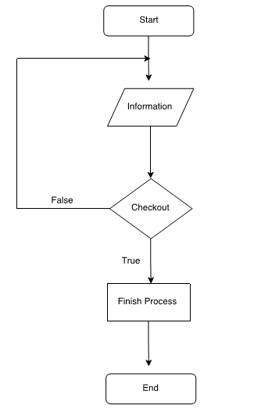

1. Search PRODUCTS

end

Display matching result

Other

Track pant

Short

Skirt

T-shirt

Shirts

Sorting out criteria

1. Purchase products

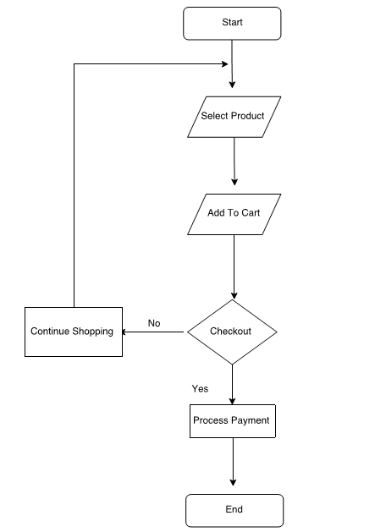

1. Login (as admin)

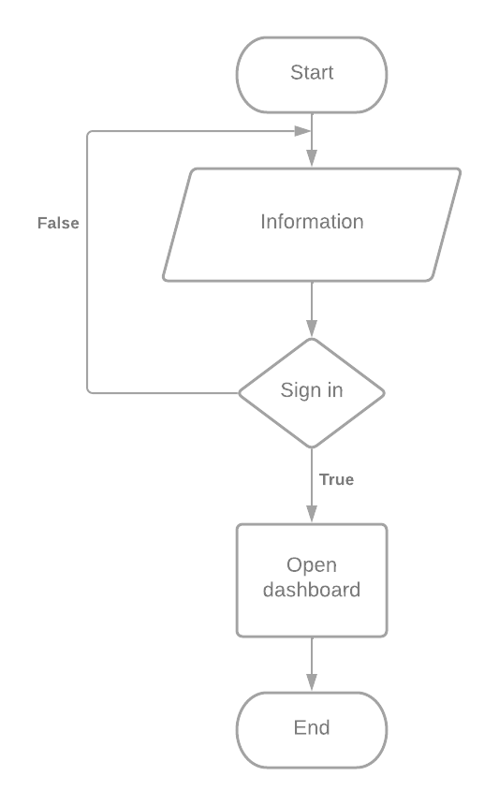

### **3. Website**

Admin email: [admin@uniform.com](mailto:admin@uniform.com)

Admin password: teamxsmb

## **IV. UI/UX**

1. [Prototype](https://docs.google.com/presentation/d/1kmryYOTOAm_GanNmcWQ5QEOHlhcMD9k0/edit?usp=sharing&ouid=115926128326476077694&rtpof=true&sd=true)
2. Screenshots

### 

### 1. Home page

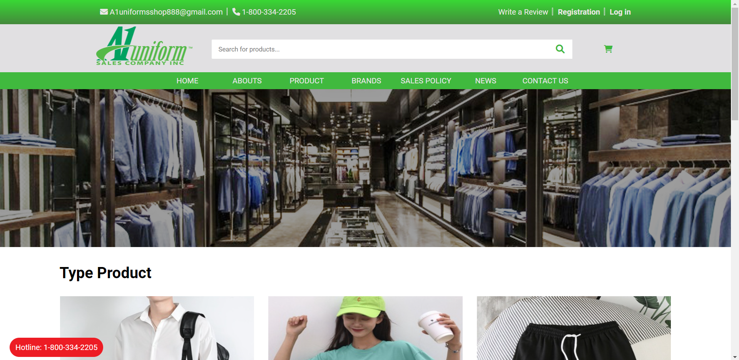

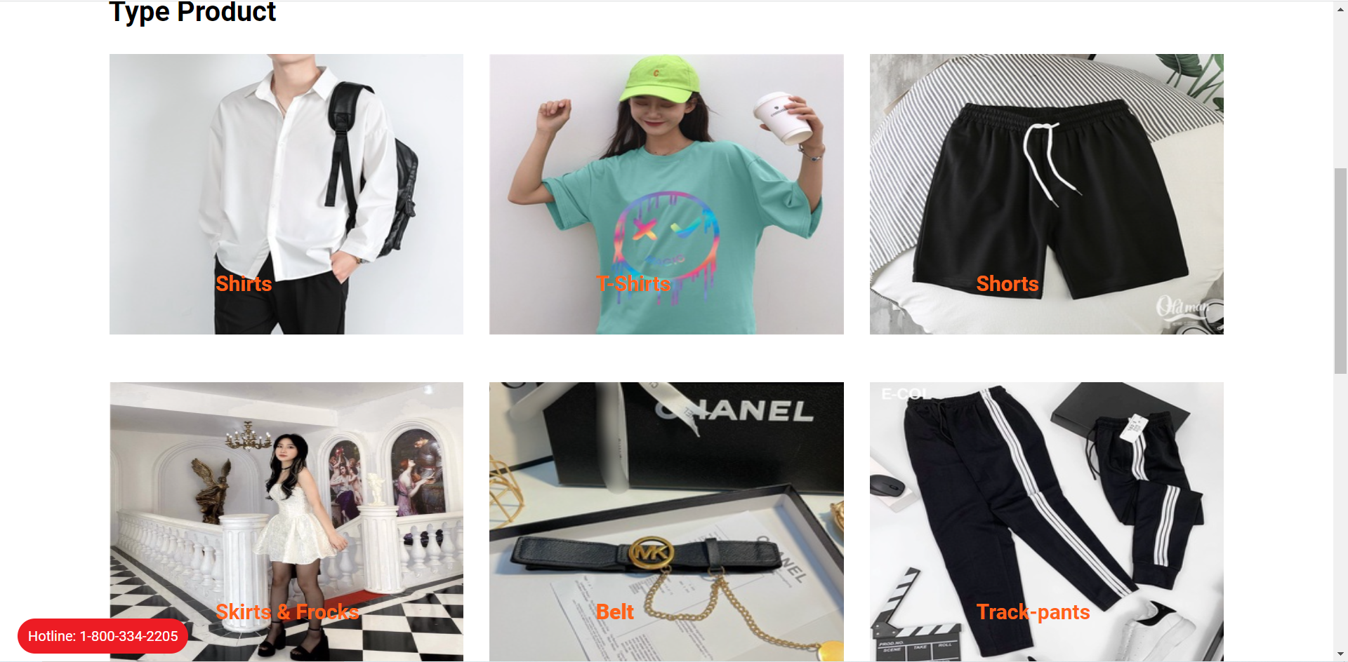

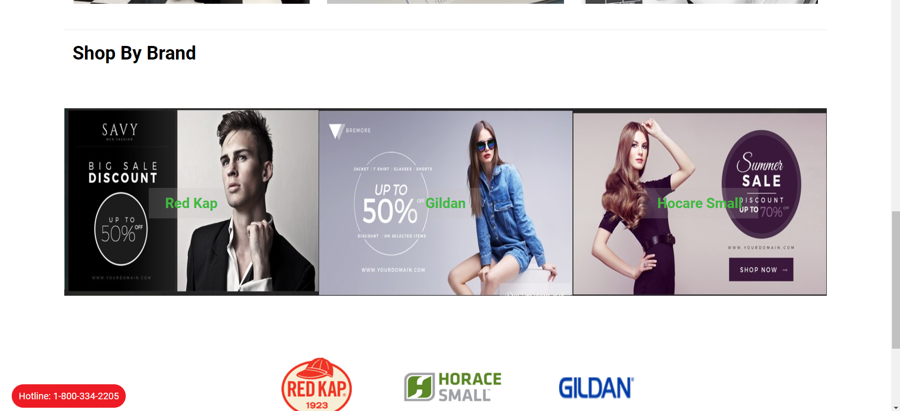

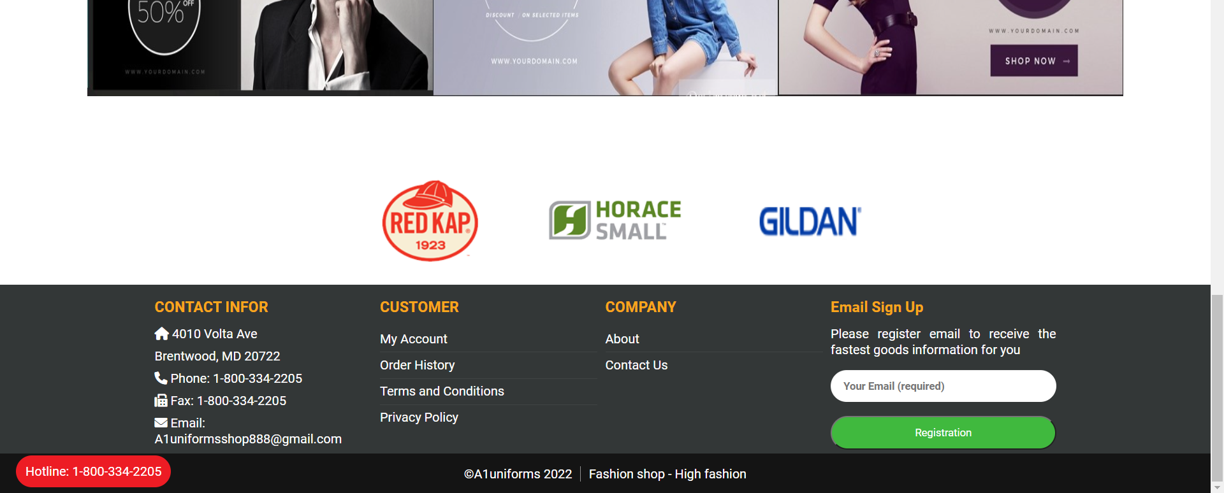

### Header

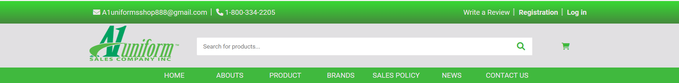

### Footer

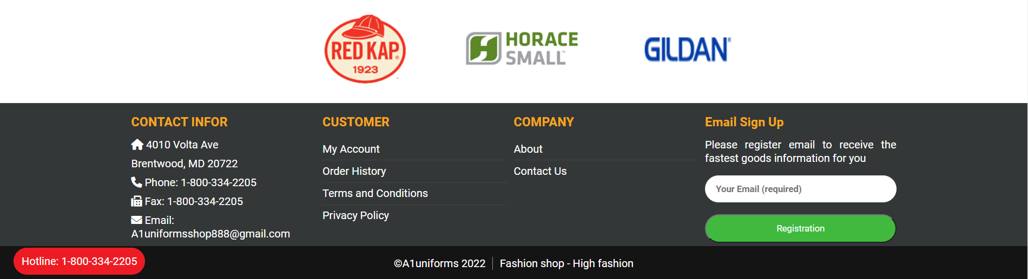

### 2. Product

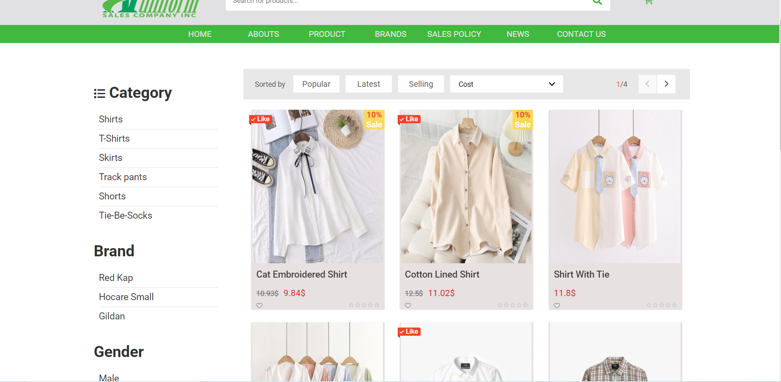

### 3. Product detail

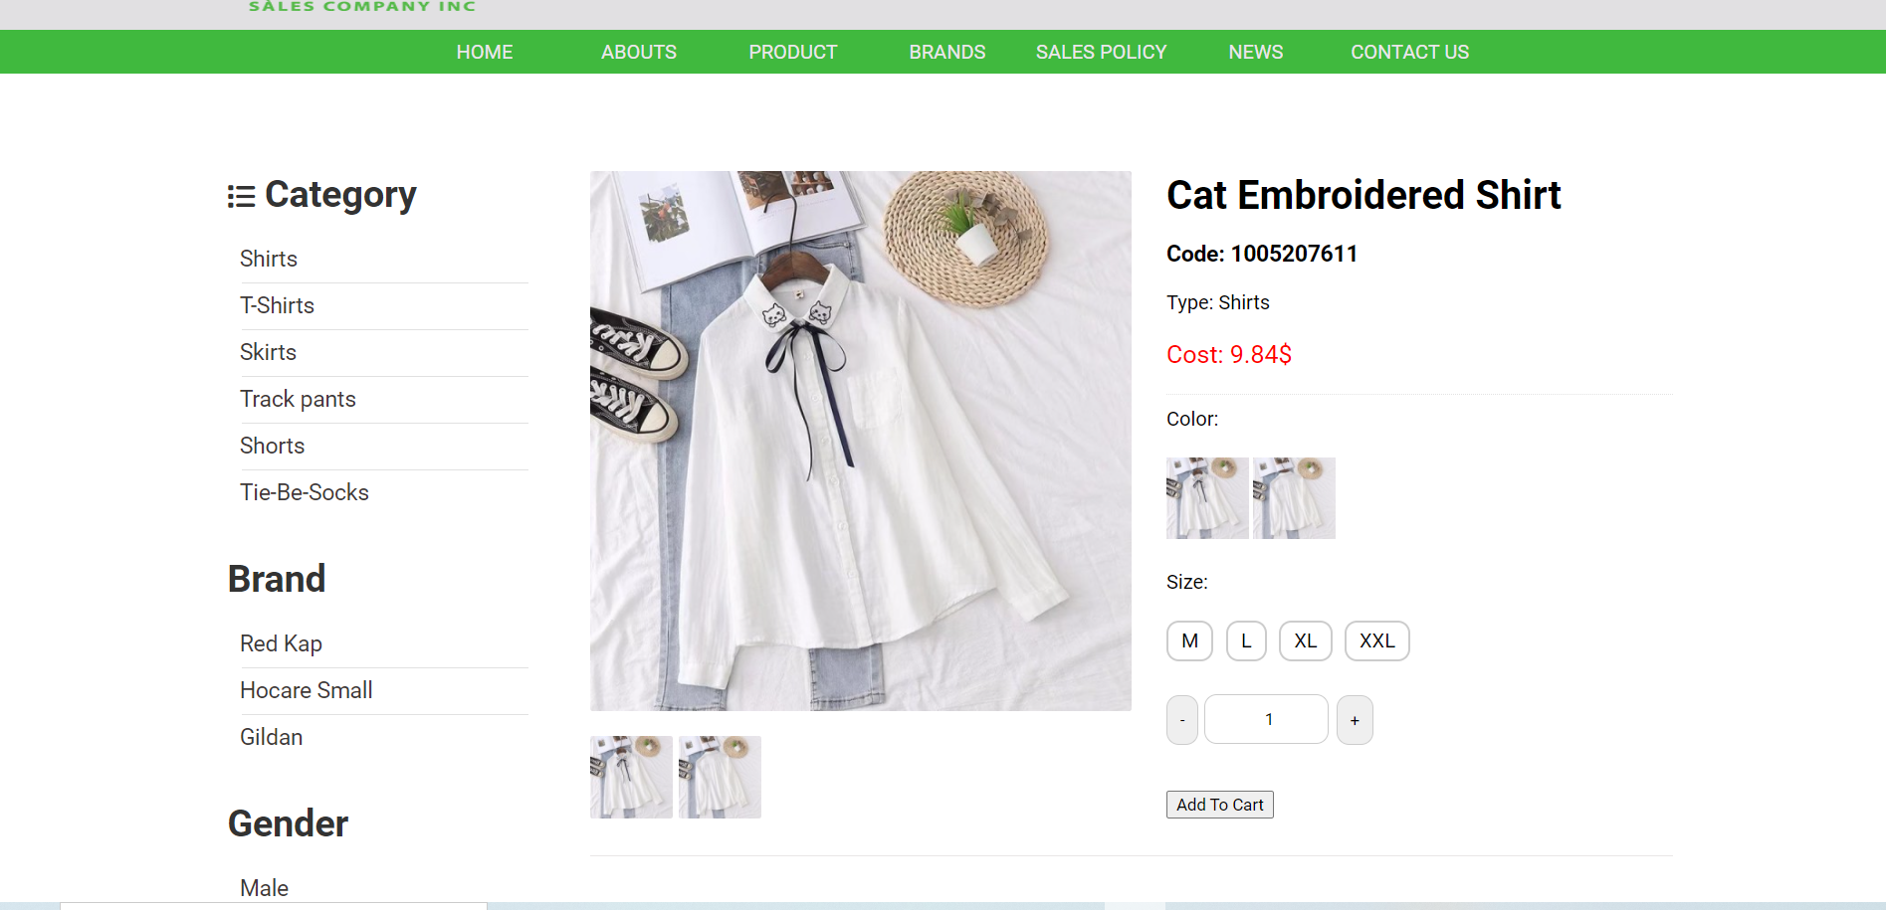

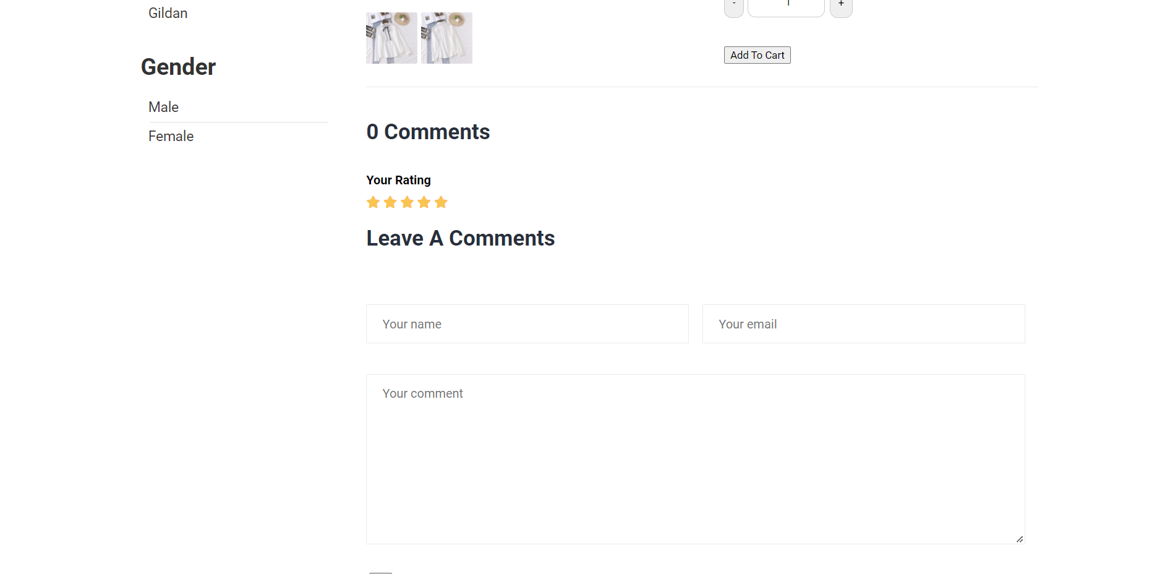

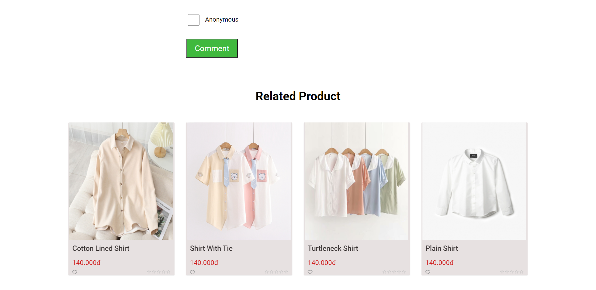

### 4. Product gender

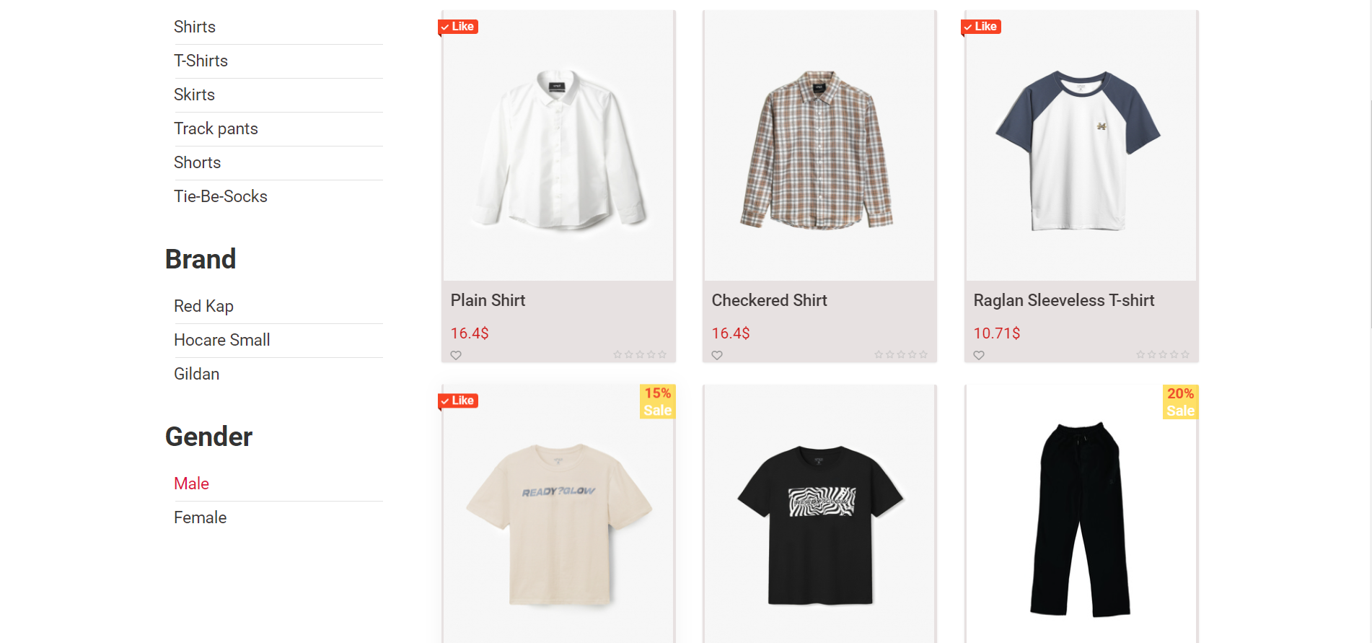

### 5. Product sale

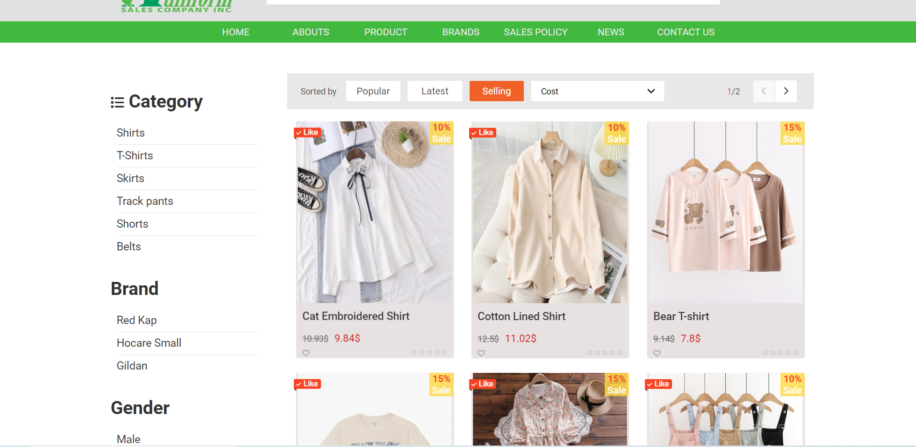

### 6. Store

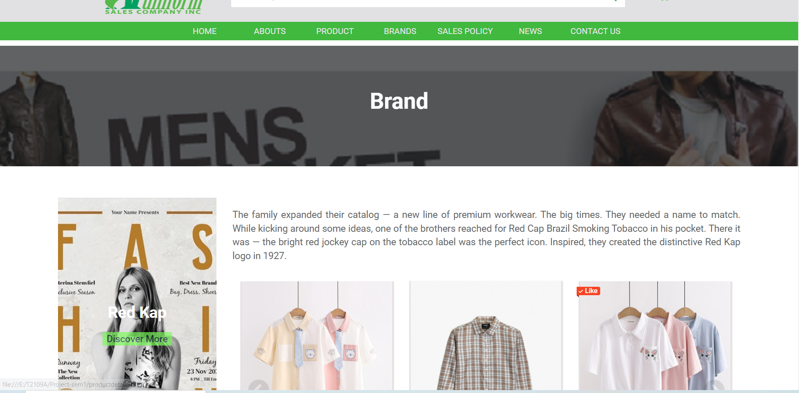

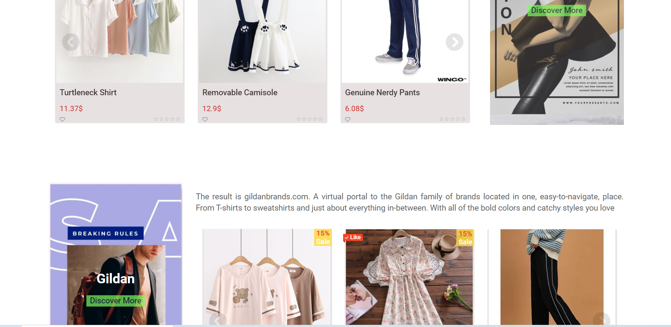

### 7. Store detail

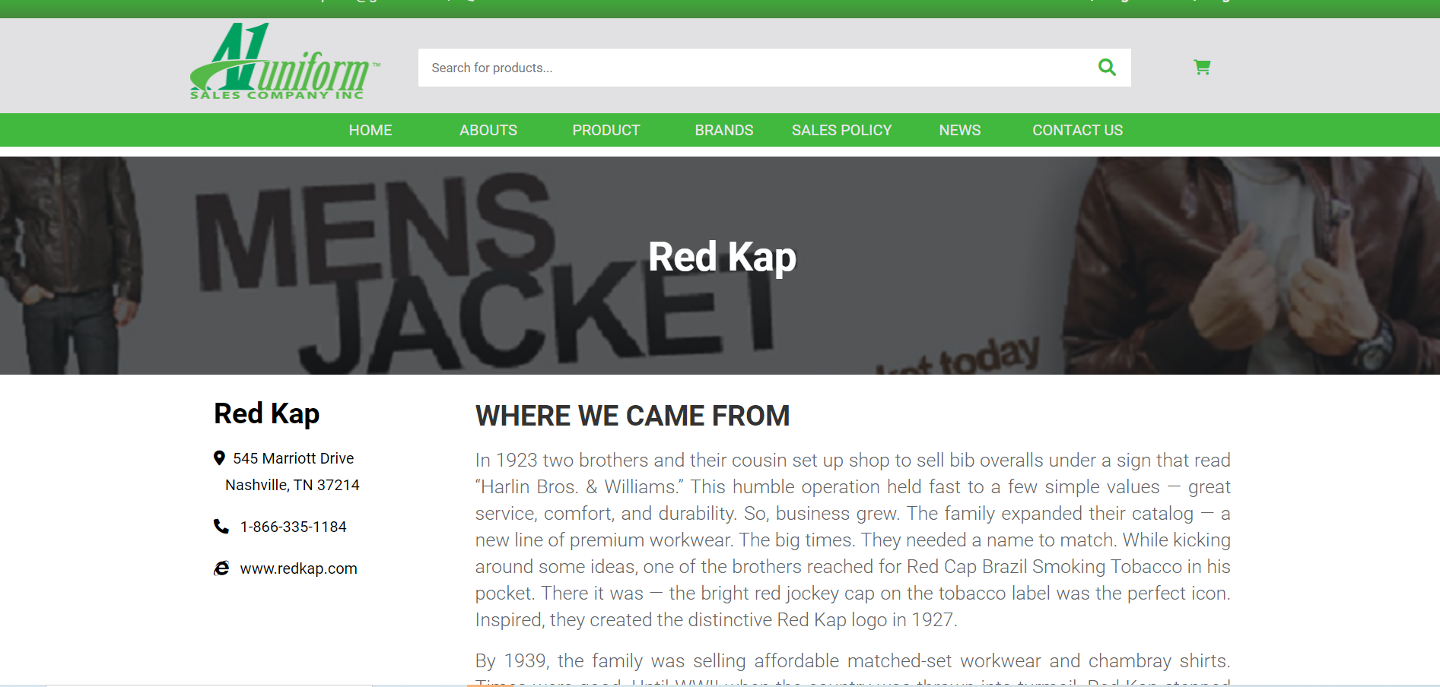

### 

### 8. About Us

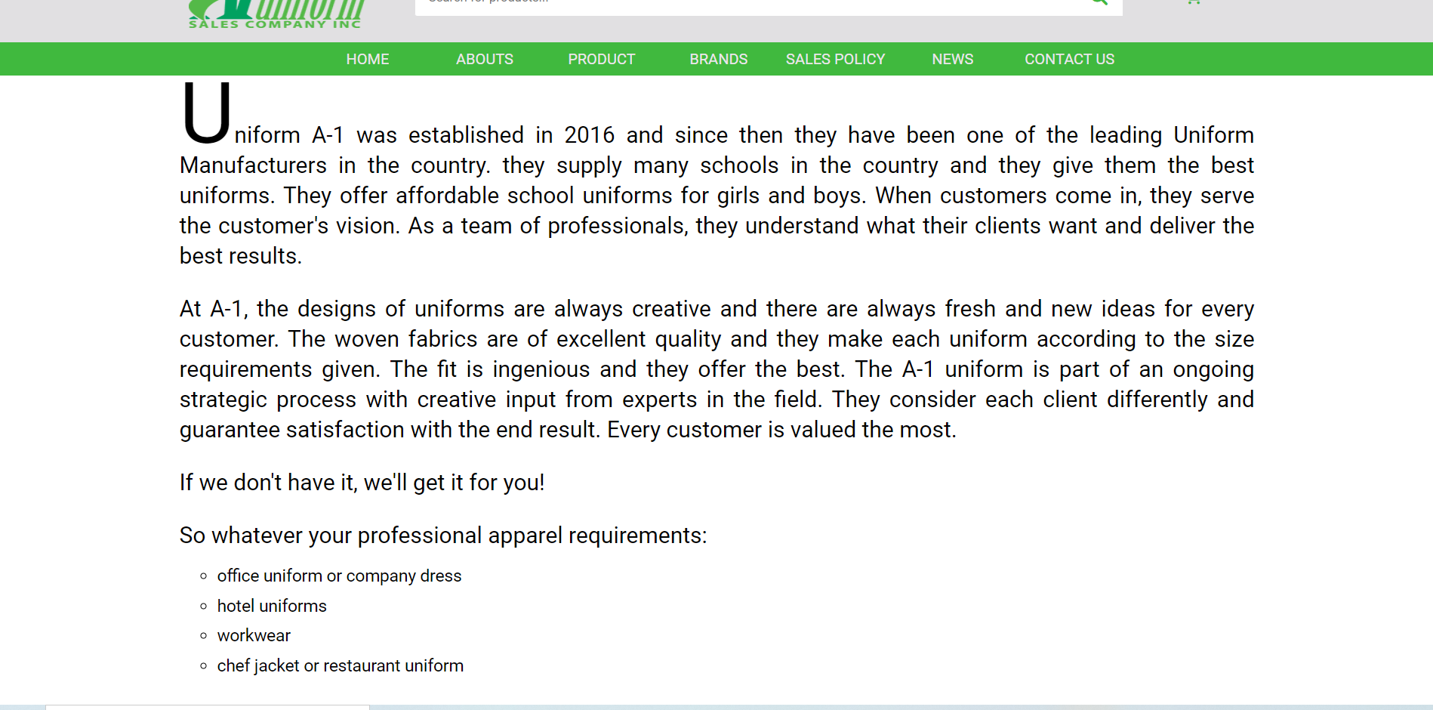

### 9. Policy

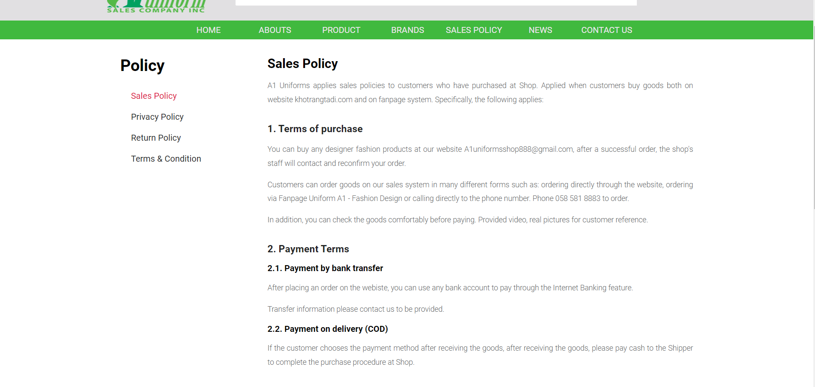

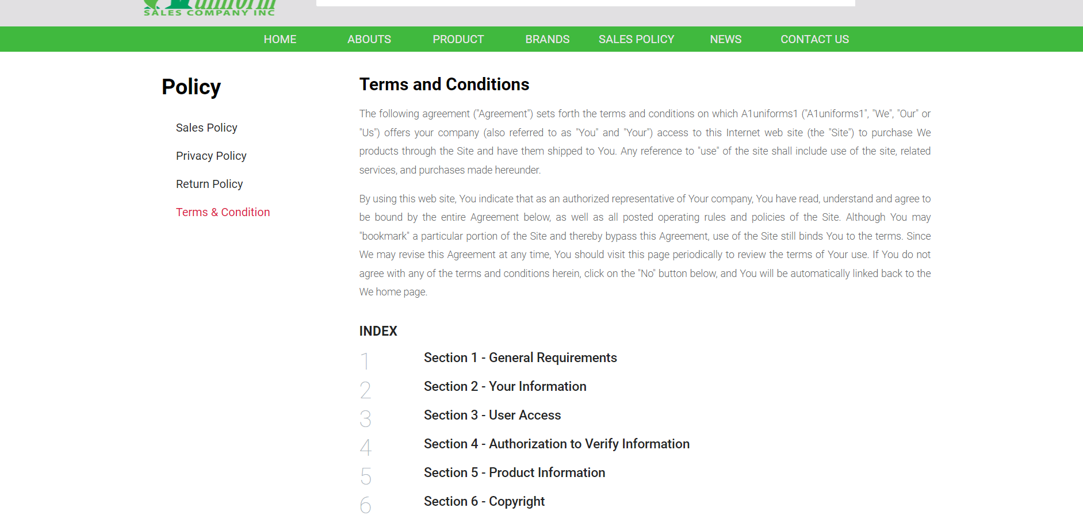

…..

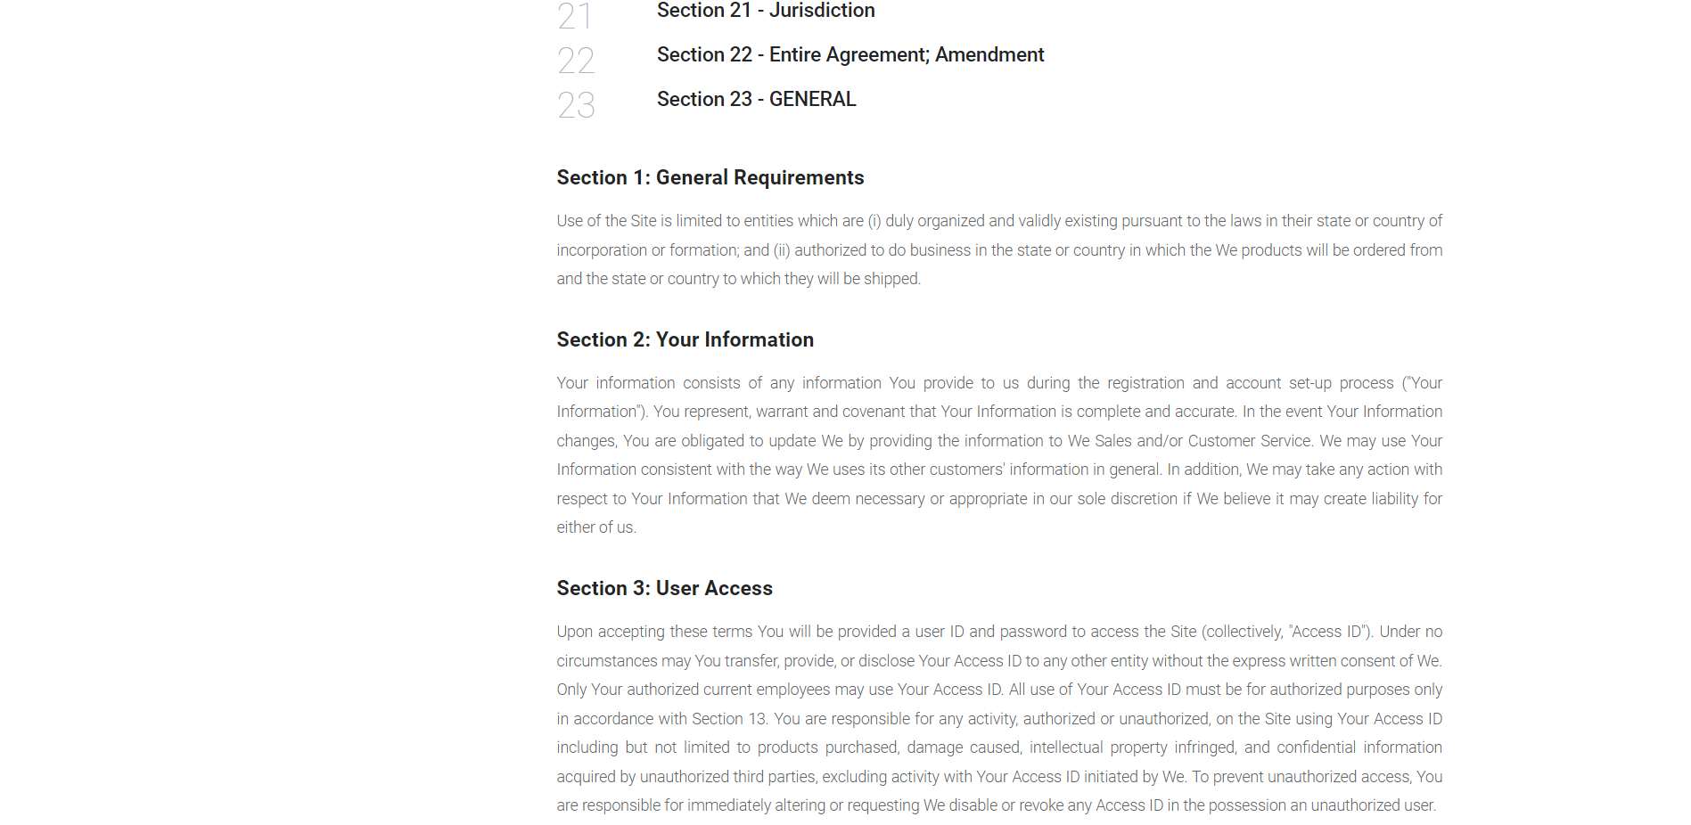

### 10. Contact Us

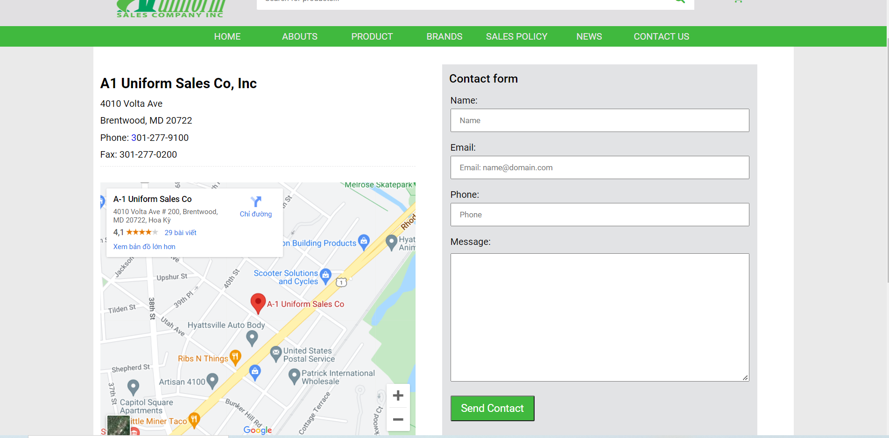

### 

### 11. Sign in / Register

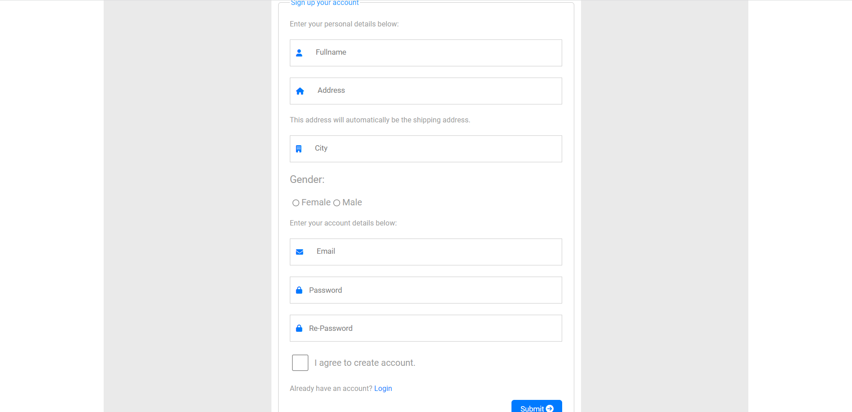

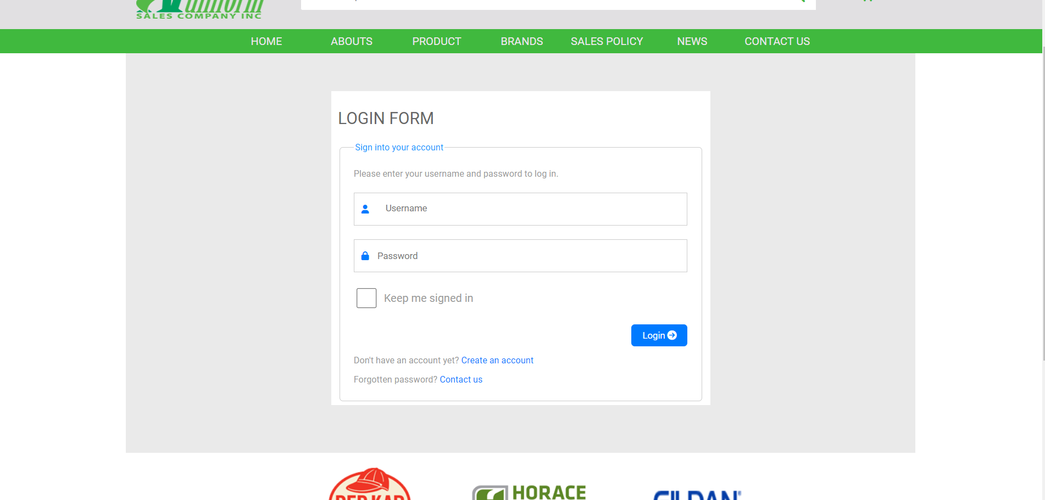

### 12. Cart

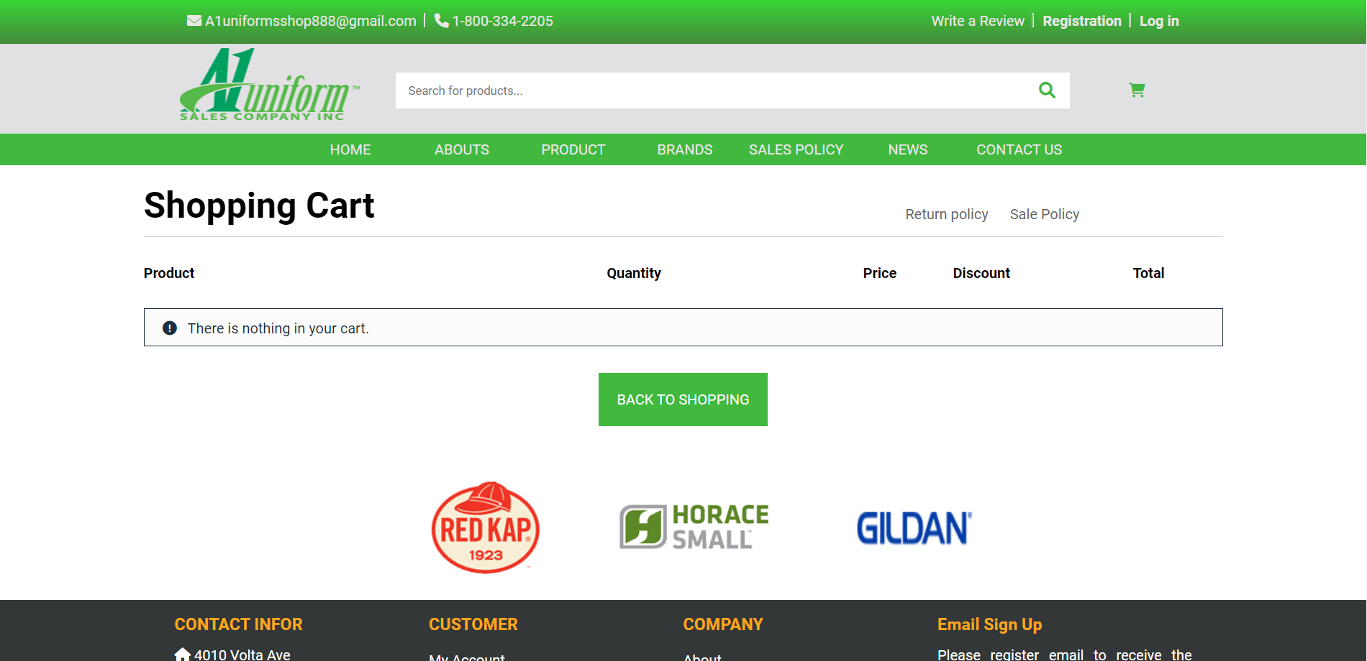

### 13. Success

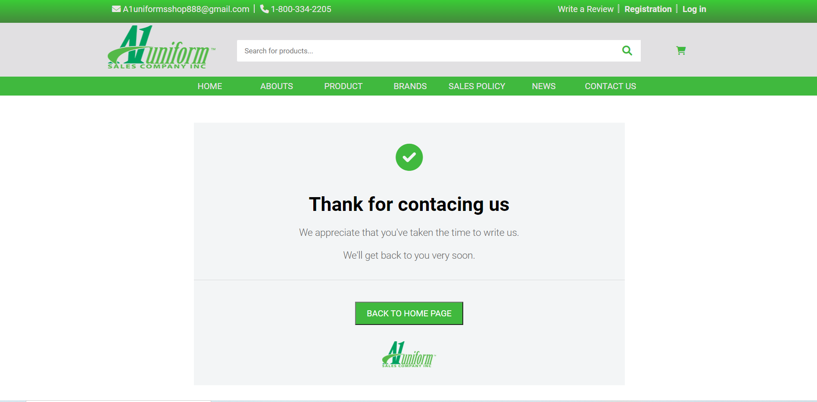

### 

14. Rating & feedback

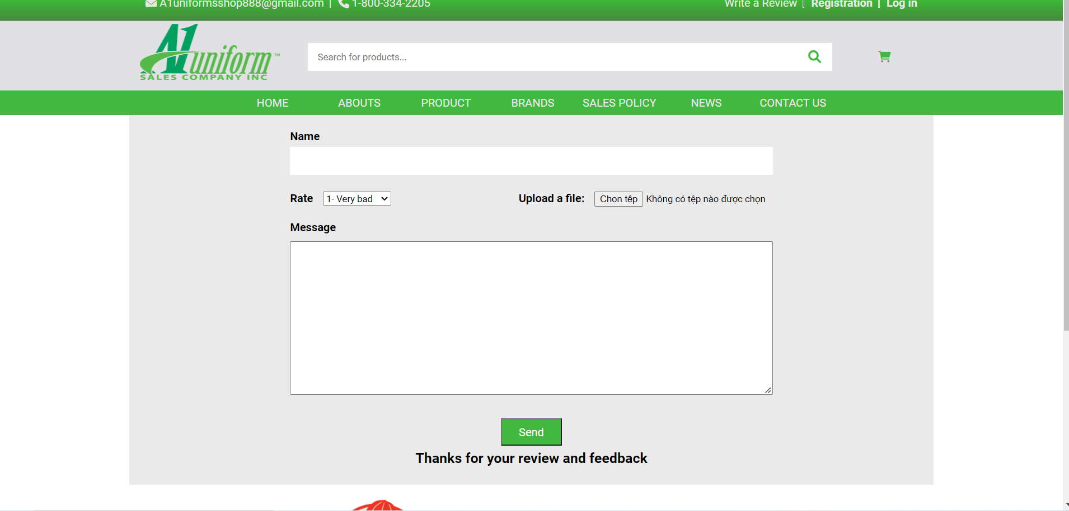

## **V. User's Guide**

Video (User guide): <​​​​https://youtu.be/freecoinsk>

Video (Admin guide):<https://youtu.be/f3st4JHi5cv>

## **VI. Summary**

## **●** Use functions in Javascript to validate forms

## ● Use functions to add events (click, blur, focusout,select, etc) to DOM elements (buttons, div, etc.) and perform actions on localStorage to store items, get items and remove items for display

## ● Use CSS to design responsive media style

## ● Use functions in Javascript and apply MVC (Model, View, Controller) structure from AngularJS

## ● Create unity in style (color, font-size, etc) from different pages in the website